Social Transformation Project

308 Paseo de la Playa, Unit 6

Redondo Beach, CA 90277

Dear Jodie Tonita, Robert Gass, & Idelisse Malavé,

Please accept the enclosed application for the position of Administrative Coordinator. I’m excited to learn more about what your company is doing currently. What you have accomplished so far is amazing. Helping organizations transform and make a difference in the world is where I want to go in my career. I know my skills can help you with that.

As the Administrative support for a unit of 15, I coordinated all incoming paperwork. I developed SharePoint sites for tracking the path of each application. I maintained internal database systems, scheduled meetings, and tracked out of office time. I designed and developed tracking and file systems, both paper based and electronic.

The compliance project took 6 tools and merged them into one smooth process. I develop a single tool to capture data, analyze it and mail merge the final documents to providers. This required research, team discussions, programming macros. To support required reporting, I also incorporated a tracking and reporting system.

I learned about transposing data to ease mail merges. Creating different templates for letters, and quality assurance processes for large mail outs. I also researched macros for mail merging PDF files using Excel and Outlook. A system within Outlook was also developed so that the team could tell who was taking care of which case. The project ends June 30, 2018.

I wrote a 48-page handbook on the process from concept to completion. This included information for the team to maintain the files used and how to fix problems in the code if needed. One team ms trained on how to change the code for future processes. This one process improved the teams output by 66%!

These are a few of the processes, projects and tools I built to support the team. Through many of the projects, there were moments of frustration knowing that I could make something work. Stepping back, getting coffee and jumping in once more lead to many solutions to the issues the team had. I look forward to the opportunity to discuss the challenges your team faces. I know I can offer suggestions for solutions and support the organization.

You can reach me at 907-707-5654 or via email at [sue@sue-a-darby.com](mailto:sue@sue-a-darby.com).

Sincerely,

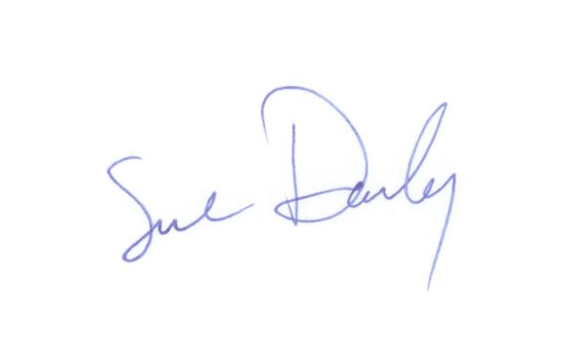

Sue Darby

|  |  |
| --- | --- |
| **Computer Skills** | **Achievements** |
| **Skills:** Technical Writing, Self-motivated, Problem Solving, Data Analytics, Universal Modelling Language (UML), WAMP  **Mark-up/Programming Languages:** HTML, CSS, JavaScript, Perl, Visual Basic.NET, BASIC A, PHP  **Databases:** MYSQL, PHPMyAdmin, CPanel, DS3, Enterprise, MMIS, Citrix, Access, COGNOS  **Office Suites:** Master Certified Microsoft Office, Project, Visio, SharePoint, OneNote, Adobe Pro, Google Suite, DropBox  **Content Management Systems:** WordPress, Drupal, Dreamweaver, Trello  **Graphic Art Suites:** Corel Draw, Inscape, Gimp, Paint Shop Pro, Freemind (mind mapping)  **Operating Systems:** Windows 3.1-10, DOS 3.3, Linux; Android | * Has written 30 or more technical software tutorials and procedural manuals * Diagram internal processes using Universal Modelling Language (UML) to increase efficacies * Using macro programming and process design facilitated a 66% increase workflow processes * Facilitated 85% increase in data collection, clean up and notification efficiency * Designated by IT as a SharePoint Administrator for 3 State of Alaska sites; develop tools, manage permissions, train new staff, participate in budget and planning meetings * 40% advancement in data capture and accuracy from changes identified and made to main database * 60% refinement in workflow from development of checklist tool, trained additional staff to maintain tool * 74% progress in time management for unit from programming of tool to track certification process * Increased file organization by 50% via a standardized electronic folder system to organize documentation * 50% improved time management; reduced management’s information systems data entry * Archive over 5,157 files using new, efficient SharePoint site for archiving reduced data loss by 45% * Creation of 46 official application forms for Medicaid Waiver Programs ensuring ADA compliance |
| **Experience** | |
| **Webmaster/Owner** ~ Alaska Office Specialists ~ Present  **Technical Writer/Webmaster/Author/Business Owner** ~ Sue’s Tiny Costumes ~ 1995 —Present  **Director** ~ Alaska Coalition for Telehealth & Telemedicine ~ 2017-Present  **Webmaster** ~ iA3 ~ 2015-2016  **Senior Services Technician** ~ State of Alaska ~ 2008 —2017  **Computer Instructor & Career Development** ~ Nine Star Education & Employment ~ 2006 - 2008 | |
| **Education** | |
| **Udemy** - Continuing Education ~ Variety of Topics ~ Ongoing  **Charter College** ~ Alpha Beta Kappa, Dean’s List  B.S. Degree in Business Management & Technology: Concentration in Business Applications  B.S. Degree in Business Management & Technology  Associate of Applied Science Degree in Computer Science: Concentration in Business Applications  Associate of Applied Science Degree in Business Management Practice  Microsoft Office Master Certification | |